


5th European Performance Engineering Workshop

EPEW 2008

Organised by the Universitat de les Illes Balears
in cooperation with the Asociación de Técnicos de Informática

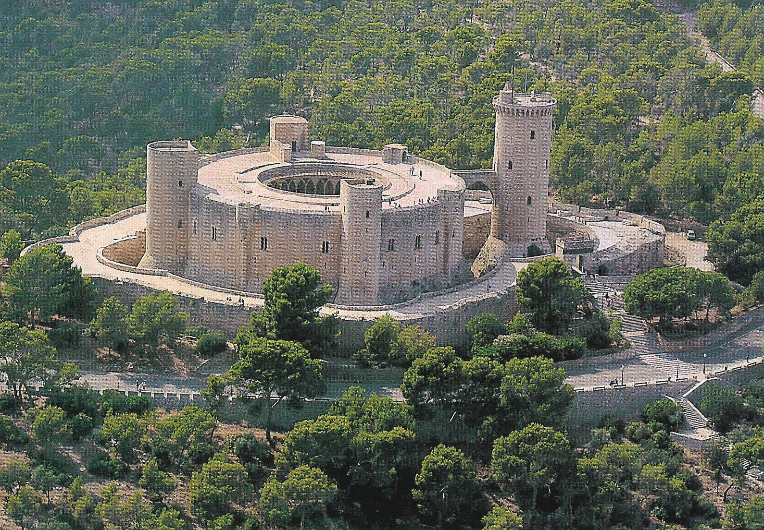

PROGRAMME

Palma de Mallorca, Spain
September 23 - 25, 2008
GENERAL CHAIR R. Puigjaner, Universitat de les Illes Balears (ES)
PROGRAM Co-CHAIRS C. Juiz, Universitat de les Illes Balears (ES)
N. Thomas, University of Newcastle upon Tyne (UK)
LOCAL ORGANIZERS B. Serra, Universitat de les Illes Balears (ES), Chair
R. Puigjaner, Universitat de les Illes Balears (ES)
C. Juiz, Universitat de les Illes Balears (ES)
C. Guerrero, Universitat de les Illes Balears (ES)
M. Khouja, Universitat de les Illes Balears (ES)
I. Lera, Universitat de les Illes Balears (ES)
P. P. Sancho, Universitat de les Illes Balears (ES)
PROGRAM COMMITTEE J. Bradley, Imperial College London (UK)
M. Bravetti, Università di Bologna (IT)
L. Cherkasova, HP Labs (US)
L. Cloth, University of Twente (NL)
T. Czachórski, Polish Academy of Sciences (PL)
J.-M. Fourneau, Université de Versailles-Saint Quentin (FR)
S. Gilmore, University of Edinburgh (UK)
A. Heindl, Universität Erlangen-Nürnberg (DE)
H. Hlavacs, University of Vienna (AT)
A. Horváth, Università di Torino (IT)
C. Juiz, Universitat de les Illes Balears (ES)
T. Kalibera, Purdue University (US)
H. Karatza, Aristotle University of Thessaloniki (GR)
L. Kloul, Université de Versailles-Saint Quentin (FR)
S. Kounev, Cambridge University (UK)
F. López Pelayo, Universidad de Castilla-La Mancha (ES)
A. van Moorsel, Newcastle University (UK)
M. Núñez Garcia, Universidad Complutense de Madrid (ES)
R. Puigjaner, Universitat de les Illes Balears (ES)
M. Ribaudo Università di Genova (IT)
M. Scarpa, Università di Messina (IT)
M. Siegle, Universität der Bundeswehr München (DE)
M. Squillante, IBM T.J. Watson Research Center (US)
A. Tai, IA Tech, Inc. (US)
M. Telek, Budapest University of Technology and Economics (HU)
N. Thomas, Newcastle University (UK)
S. Wittevrongel, Universiteit Gent (BE)
K. Wolter, Humboldt Universität zu Berlin (DE)

LOCATION
The sessions will be held at the Conference room (Sala d’Actes) of the Cas Jai building in the UIB campus (Valldemossa road km 7.5).

VENUE
Ca’s Jai building at University of the Balearic Islands main campus (Universitat de les Illes Balears, UIB). See map at http://www.uib.es/ca/infsobre/universitat/campus/planols/edificis.pdf
Ca’s Jai building is a small house located in the south side, near the metro station (exiting from the metro station go right).

TRANSPORTATION
A bus will pick up the conference attendees at the official hotels at 08:00 on Tuesday 23 and at 07:30 the other two days to bring them to the conference site. At the end of the sessions a bus will transport the attendees to the official hotels.

There is metro connection every 15 min. (from 7:00 a.m. until 20:30 p.m. / and every 30 min. before and after this period) from Plaça d’Espanya (Plaza de España) intermodal train station to Universitat de les Illes Balears (UIB) main campus (last stop) every 15 min. However, the main train station is located at financial and commercial district far from hotels.

http://tib.caib.es/index.en.htm

http://www.mallorcaquality.com/index/paginasgenerales/metro_palma_mallorca_estacion_intermodal.htm

KEY NOTE SPEAKERS

Boudewijn HAVERKORT, UCLA (USA)
Biography
Dr. Haverkort is full professor for Design and Analysis of Communication Systems at the University of Twente, in the faculty for Electrical Engineering, Mathematics and Computer Science since 2003. He is heading the group Design and Analysis of Communication Systems whose main research lines are measurement and management of operational network systems, protocol and algorithm design and implementation, and model-based design of (embedded) communication systems. Previously he studied Computer Science at the University of Twente in Enschede where he earned his M.Sc in 1986, and his Ph.D. in 1991. From January 1990 through September 1995, he was a lecturer at the University of Twente, and in the spring of 1993 I was a visiting scientist in the Teletraffic Research Centre at the University of Adelaide in Australia. From October 1995 through December 2002, he was a C3-professor for Distributed Systems in the Department of Computer Science at the Rheinisch-Westfälische Technische Hochschule in Aachen, Germany.
He is active in a number of international scientific organizations: Fellow of IEEE in particular of Computer and Communication societies, Member of IFIP WG6.3 on Performance of communication systems and WG7.3 Computer performance modeling and analysis, and Member of ACM in particular of Sigmetrics and Sigcomm. He serves on the editorial board of the journal Performance Evaluation. He is author of a textbook on performance evaluation of computer-communication systems (Wiley, 1998), has published 5 conference proceedings (IEEE, Springer) and did put together multi-author books on performability (Wiley, 2001) and on validation of stochastic systems (Springer, 2003). He has published around 75 paper in journals and at (full-review) conferences. He has been general and/or programme chair of a number of international conferences (TOOLS 2000, PNPM 2001, MMB 2001, QEST 2004, DSN/PDS 2005, PDMC 2006, PDMC 2007), and have been a member of numerous scientific programme committees.

Stephen Gilmore, University of Edinburgh (UK)
Biography

Stephen Gilmore is a Reader in the School of Informatics at the University of Edinburgh. He obtained his PhD from the Queens University of Belfast in 1990 and when he moved to Edinburgh continued with his interests in program specification and verification. At Edinburgh he became interested in performance evaluation and the application of quantitative analysis to understanding computer systems. He collaborated with Jane Hillston on software tools for the PEPA stochastic process algebra, focusing on analysis by numerical evaluation of continuous-time Markov chains. His recent work has widened to include stochastic simulation and continuous-space modelling of large-scale systems initiated from high-level process calculus models.

TUESDAY SEPTEMBER 23

08:00 Bus departure from the hotels

08:45 Registration

09:15 Welcome and opening address: Workshop Co-chairs

09:30 Keynote SPEECH (PETER Harrison (Imperial college))

10:30 Coffee break

11:00 Session 1: APPLICATIONS IN bIOCHEMISTRY
(Chair: Jeremy Bradley)

Integrated Simulation and Model-Checking for the Analysis of Biochemical Systems
Federica Ciocchetta, Stephen Gilmore, Maria Luisa Guerriero and Jane Hillston

An Irreversibility Study of the Interactions between Cdk and APC in the Budding Yeast Cell-Cycle
Paolo Ballarini, Tommaso Mazza, Alida Palmisano and Attila Csikasz-Nagy

11:50 Session 2: Petri Nets Applications

(Chair: Nigel Thomas)

Performance Analysis of the ARIA Adaptive Media Processing Workflows using Colored Petri Nets
Maurizio Garelli and Marco Gribaudo

Automated Customer-Centric Performance Analysis of Generalised Stochastic Petri Nets Using Tagged Tokens
Nicholas Dingle and William Knottenbelt

12:40 Light Lunch break

14:00 Session 3: COMPUTER APPLICATIONS (I)

(Chair: William Knottenbelt)

A Statistically Customisable Web Benchmarking Tool
Katja Gilly, Carlos Quesada-Granja, Salvador Alcaraz, Carlos Juiz, Ramon Puigjaner

Application of Queueing Network Models in the Performance Evaluation of Database Designs
Rasha Osman, Irfan Awan, Michael E. Woodward

Diffusion approximation model of multiserver stations with losses
Tadeusz Czachórski, Jean-Michel Fourneau, Tomasz Nycz and Ferhan Pekergin

15:15 Coffee break

15:45 Session 3: COMPUTER APPLICATIONS (Ii)

(Chair: Nigel Thomas)

Performance Analysis of a Software Retrieval Service
Leïla Kloul

Modelling Grid5000 point availability with SAN
Leonardo Brenner, Paulo Fernandes, Jean-Michel Fourneau and Brigitte Plateau

16:00 Workshop Close

18:00 Guided tour around the old town of Palma starting at the Town Hall (Plaça de Cort)

20:00 Reception at the Palma Town Hall building
Offered by the Palma Town Hall

WEDNESDAY SEPTEMBER 24

07:30 Bus departure from the hotels

08:00 Registration and breakfast

08:30 Opening Session

09:00 Keynote Speech i

Performance and Dependability Evaluation: Successes, Failures and Challenges
Boudewijn Haverkort, University of Twente (NL)

10:00 Session 1: SOFTWARE PERFORMANCE eNGINEERING

(Chair: Carlos Juiz)

An Empirical Investigation of the Applicability of a Component-Based Performance Prediction Method
A. Martens, S. Becker, H. Koziolek, R. Reussner, University of Karlsruhe (DE)

A Calibration Framework for Capturing and Calibrating Software Performance Models
X. Wu. M. Woodside, Carleton University (CA)

Performance Evaluation of Embedded ECA Rule Engines: a Case Study
P. Guerrero, K. Sachs, S. Butterweck, A. P. Buchmann, Technische Universität Darmstadt (DE)

11:30 Coffee break

11:45 Session 2: COMPUTER AND COMMUNICATIONS NETWORKS

(Chair: Jean-Michel Fourneau)

Natural Language Specification of Performance Trees
L. Wang, N. Dingle. W. Knottenbelt, Imperial College London (UK)

Recurrent Method for Blocking Probability Calculation in Multi-service Switching Networks with BPP Traffic
M. Glabowski, Poznan University of Technology (PO)

An Approximate Model of the WCDMA Interface Servicing a Mixture of Multi-Rate Traffic Streams with Priorities
D. Parniewicz, M. Stasiak, J. Wiewiora, P. Zwierzykowski, Poznan University of Technology (PO)

13:15 Light Lunch break

14:45 Session 3: APPLICATIONS

(Chair: Ramon Puigjaner)

Stochastic Bounds for Partially Generated Markov Chains: an Algebraic Approach
A. Busic, INRIA Grenoble (FR), J.-M. Fourneau, Université de Versailles-St-Quentin (FR)

Evaluation of P2P algorithms for Probabilistic Trust Inference in a Web of Trust
H. Zhang, A. van Moorsel, Newcastle University (UK)

15:45 Bus departure from the campus

21:00 Workshop Banquet

THURSDAY SEPTEMBER 25

07:30 Bus departure from the hotels

08:00 Registration and breakfast

08:30 Session 4: STOCHASTIC PROCESS ALGEBRA AND SANs

(Chair: Stephen Gilmore)

Towards State Space Reduction Based on T-Lumpability-Consistent Relations
M. Bernardo, Universitá di Urbino “Carlo Bo" (IT)

A ticking clock: Performance analysis of a Circadian rhythm with stochastic process algebra
J. Bradley, Imperial College London (UK)

Assembly Code Analysis using Process Algebra
L. Djoudi, L. Kloul, Université de Versailles-St-Quentin (FR)

Product form steady-state distribution for Stochastic Automata Networks with Domino Synchronizations
J.-M. Fourneau, Université de Versailles-St-Quentin (FR)

10:30 Coffee break

11:00 Session 5: PERFORMANCE QUERY SPECIFICATION AND MEASUREMENT

(Chair: Nigel Thomas)

State-Aware Performance Measurement with eXtended Stochastic Probes
A. Clark, S. Gilmore, University of Edinburgh (UK)

11:30 Session 6: QUEUEING THEORY AND MARKOV CHAINS

(Chair: Nigel Thomas)

Performance Analysis of Dynamic Priority Shifting
P. Reinecke, K. Wolter, J. Zapotoczky, Humboldt-Universität zu Berlin (DE)

Performance analysis of a priority queue with place reservation and general transmission times
B. Feyaerts, S. Wittevrongel, Universiteit Gent (BE)

Analysis of BMAP/G/1 vacation model of non-M/G/1-type
Z. Saffer, M. Telek, Technical University of Budapest (HU)

13:00 Light Lunch break

14:30 Keynote Speech ii

Partial Evaluation of PEPA Models for Fluid-flow Analysis
Stephen Gilmore, University of Edinburgh (UK)

15:30 CLOSING Session

16:00 Bus departure from the campus

