

Requirements Specification
Project Name: Stock Management System
Team Number 5

Document Information
Project Name: Stock Management System
Prepared By:Team 5 |  | Preparation Date:
Email / Phone:
Document Version No: | 1.0 | Document Version Date: xx/xx/xx
Version History
Ver. No. | Ver. Date | Revised By | Description
1.0 | 15/11/2018 | David Petrie | Project documentation setup
1.1 | 25/11/2018 | David Petrie | Collecting & proof reading groups contributions
1.2 | 09/12/2018 | David Petrie | Collecting & editing work to fit same style
1.3 | 11/12/2018 | David Petrie | Final editing and preparation for submission
1.4 | 25/03/2019 | Lee Rickwood | Initial changes based upon feedback
1.5 | 12/04/2019 | Lee Rickwood | Finalising further changes

Table of Contents

- Background & Analysis…………………………………………………………………………………………………………………………
  - Analysis & Process…………………………………………………………………………………………………………………………
  - Analysis…………………………………………………………………………………………………………………………………………
  - Scope…………………………………………………………………………………………………………………………………………….
  - Risk Analysis………………………………………………………………………………………………………………………………….
- Hardware & Software platforms to be used for developing and running your solution……………………….
- Solution Requirements………………………………………………………………………………………………………………………..
  - Functional Requirements………………………………………………………………………………………………………………
  - Non-Functional Requirements………………………………………………………………………………………………………
- Other Considerations………………………………………………………………………………………………………………………….
  - Assumptions………………………………………………………………………………………………………………………………..
  - Constraints & Dependencies……………………………………………………………………………………………………….
- Initial Requirements Analysis of User Interaction……………………………………………………………………………….
  - Initial Ideas for a GUI…………………………………………………………………………………………………………………..
  - Website Design……….…….…….…….…….…….…….…….…….…….…….…….…….…….…….…….…….…….……….
- UML Diagram…………………..…………..…………..…………..…………..…………..…………..…………..………………………..
- Use Cases…………………………………………………………………………………………………………………………………………..
6.1 Use Case Diagram……………………………………………………………………………………………………………………….
6.2 User Access…………………………………………………………………………………………………………………………………
- References…………………………………………………………………………………………………………………………………………
- Definition of Terms…………………………………………………………………………………………………………………………….
- GANNT Chart……..……..……..……..……..……..……..……..……..……..……..……..……..……..……..……..……..………….

Purpose (Executive summary)

Chicken Lovers United Kingdom (CLUK) has asked our team to design, implement and test a new system to keep on track with stock management which should include all stock at their central warehouse and restaurants located in the North East of England.
The team has then identified the key stakeholders for the project and completed a background analysis of other available products on the market. This analysis allowed the team to identify what is in and outside of the scope of the project for the forthcoming implementation. A risk analysis was carried out to ensure that all appropriate risks are accounted for and solutions to potential risks are available should the team run into difficulties.
A software and hardware analysis helped the team to define the functional and non-functional requirements for the project and given us a set of deliverables for the team to aim towards. In combination with the constraints and assumptions this allows the end users to ensure that the project is being built on an appropriate list of deliverables.
From these requirements a mock up website has been built to visually show what our initial interpretation of the project will look like and give us a basis for us to build towards. Based on this functionality and website use cases were built to show exactly what responses interacting with the website will trigger.
Finally, a GANNT chart was produced to represent the team’s timeline and projected completion dates for the stages of the project.

--------------------------------------------------------------------------------------------------------------------------

The Remainder of the document must contain:

- Background & Analysis
  - Analysis Process

Distribution Centre Location:

- 2 Drum Rd, Chester le Street, DH2 1AB
Restaurant Locations:

- Seaton Burn Services, Fisher Lane, Newcastle upon Tyne NE13 6BP
- Alnwick Town Centre, 19 Lagny Street, Alnwick, NE66 1LA
- Newton Aycliffe, 4 Northfield Way, Newton Aycliffe, DL5 6EJ
- Thirsk Town Centre, 26 Market Place, Thirsk YO7 1LB
- Whitby Town Centre, Station Square, Whitby YO21 1DX

The company have made specific requirements for the management system, which include reducing as much food waste as possible, being able to track units of items in the deliveries, generating delivery schedules for drivers, having a system which updates the central warehouse of stock which is required in restaurants and keeping track of the stock held at the central warehouse.

In order to gain an appreciation of what can be achieved to fulfil the end users’ requirements, previous examples of stock management systems in larger fast food chains were analysed. The first of which was the system belonging to McDonald’s. Firstly, they categorised their management system into different types. These included raw ingredients (frozen, chilled and ambient items), work in progress products (burger patties, sauces, lettuce, buns and other items which are used to form a single product) and finally finished products which are used to make an immediate sale.
McDonald’s Supply Planning Department claimed this method of stock management would reduce wastage and provide more accurate forecasting of future demand for products. In order to accurately forecast sales, their system analyses data from the previous two years and considers multiple factors that affect sales including but not limited to national and school holidays, promotions and traffic issues that could affect deliveries.
Another function of this Stock Management System is that it implements a first in first out system – ensuring ingredients are fresh and of good quality whilst reducing waste.
The specific use of a weblog, a web-based application designed to allow restaurant users and supplies to receive daily updates of stock levels and amend stock levels when necessary has been noted in the case study seen in the McDonald’s Stock Management System. However, the use of proprietary and cloud based services are also a popular choice among fast food businesses.

A solution to linking the supply chain between ordering stock from the warehouse and each of the restaurants can be observed in both the SimpleOrder. and KitchenCut inventory management systems. This system is a cloud integrated plug and play software that allows restaurant chains and their supplies to wholly manage the process of managing stock and ordering inventory online. It allows for real time data on inventory levels and costing of deliveries

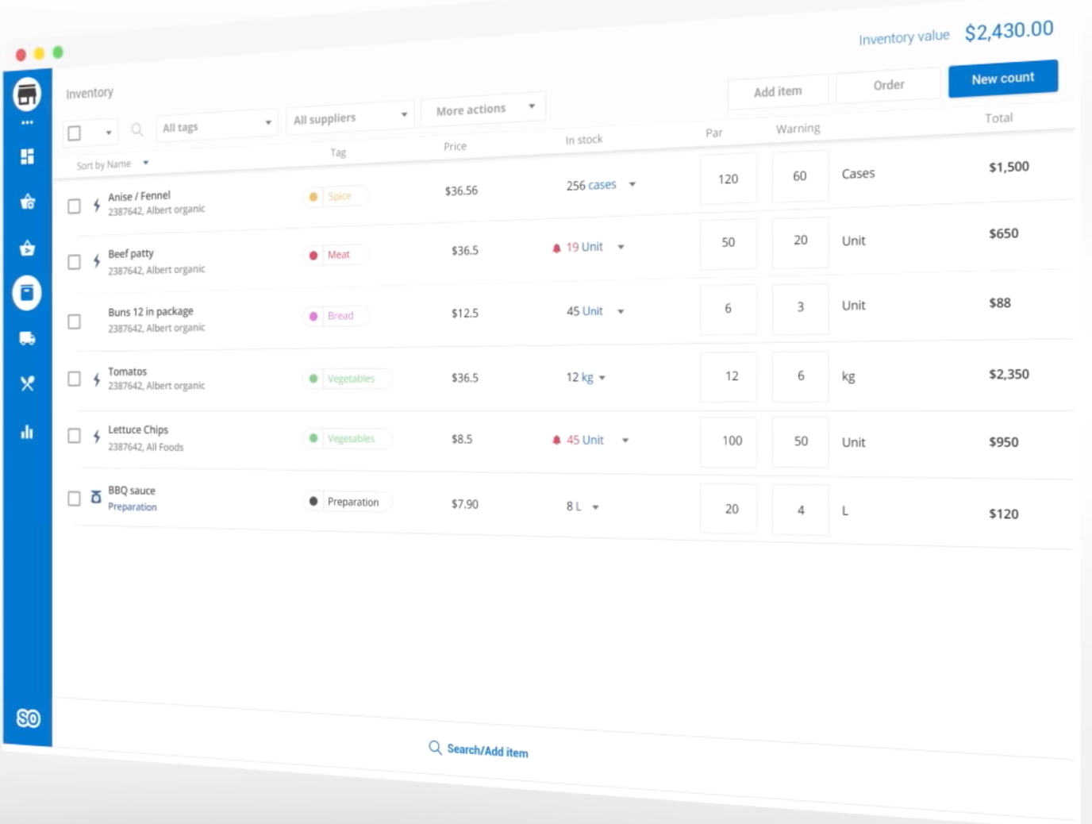
Figure 1 - Screenshot showing the SimpleOrder Stock Management System

In the above screenshot certain ingredients can be seen with information including the current levels of stock and the cost and quantity of orders from the supplier. In the event that a restaurant uses an ingredient, e.g when a burger is sold. The corresponding ingredients will be automatically deducted from the inventory of the restaurant and this is handled in real time by the Stock Management System. In this system the restaurant manager can also set at which point they wish to be notified at diminishing stock levels as seen in the warnings column.

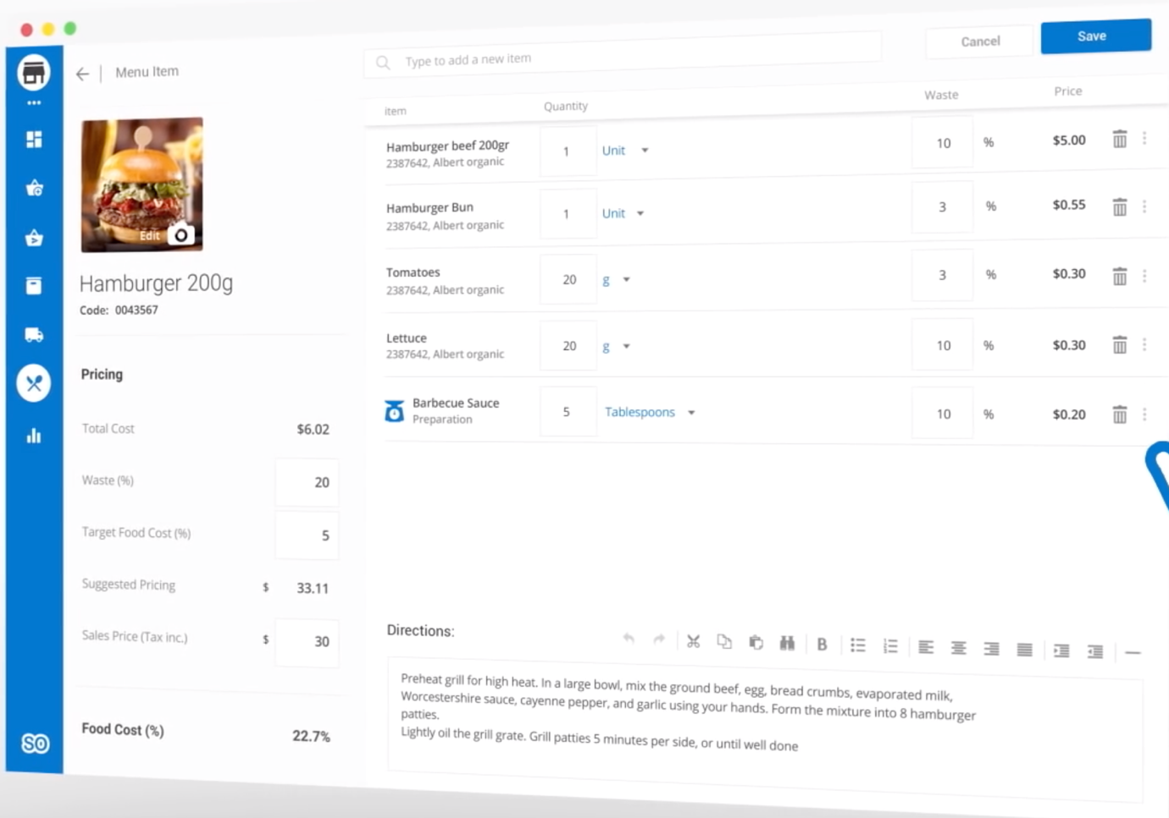
Figure 2 - Adding a new product

Figure 2 shows a new product being created by the restaurant. The SimpleOrder software allows for this to be easily achieved and includes the ability to add which specific ingredients are included in the product. This will then allow for each of these ingredients to be deducted from the stock inventory levels in real time when the new product is sold to a customer.

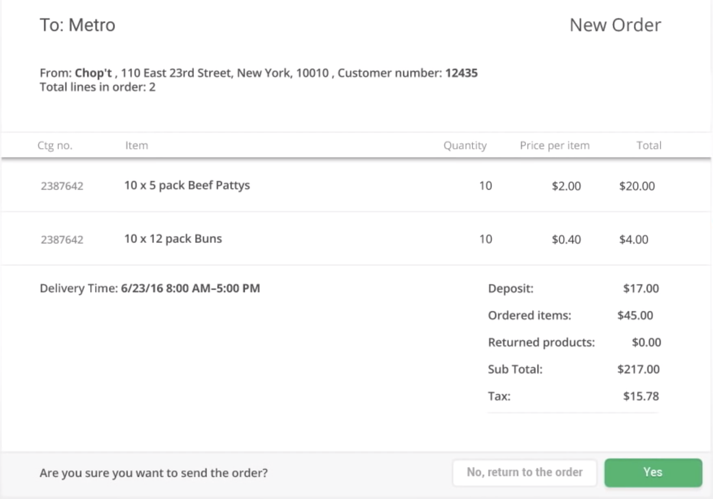
Figure 3 - Ordering of ingredients from the supplier

Creating orders from a supplier or warehouse is simple and efficient with Simple Order. Quantity and items ordered are selected from the interface showed in figure 1 then reviewed for confirmation as shown in figure 3.
The Simple Order Stock Management System is a simple to use solution for tracking real time stock levels and ordering new stock. It also included functions helpful to restaurants such as creating new products whilst linking to the stock levels of the ingredients that are used in that product being able to make amendments to the stock levels when necessary – either deductions when sales are made or additions when a delivery is made from the supplier/warehouse.
Criticisms of simple order include its high subscription cost in addition to the required hardware. SimpleOrder relies on the user having access to tablets such as iPad and these will need to be purchased, maintained and updated for each restaurant. A hardware issue here will also be a critical problem if the stock management system is wholly reliant on them. Another noted flaw with SimpleOrder is a lack of security. Currently there are no user groups for different staff levels, so all members of staff have access to all permissions. There is currently no way of setting an option where it requires a special user – such as a Manager – to review an order before confirmation. It would be necessary for lower level restaurant staff to have access to stock levels and receive notifications regarding low stock warnings without the ability to themselves carry out an order.

KitchenCut is another example of a cloud-based solution available for restaurants that provides functionality such as inventory management and a point of sale interface

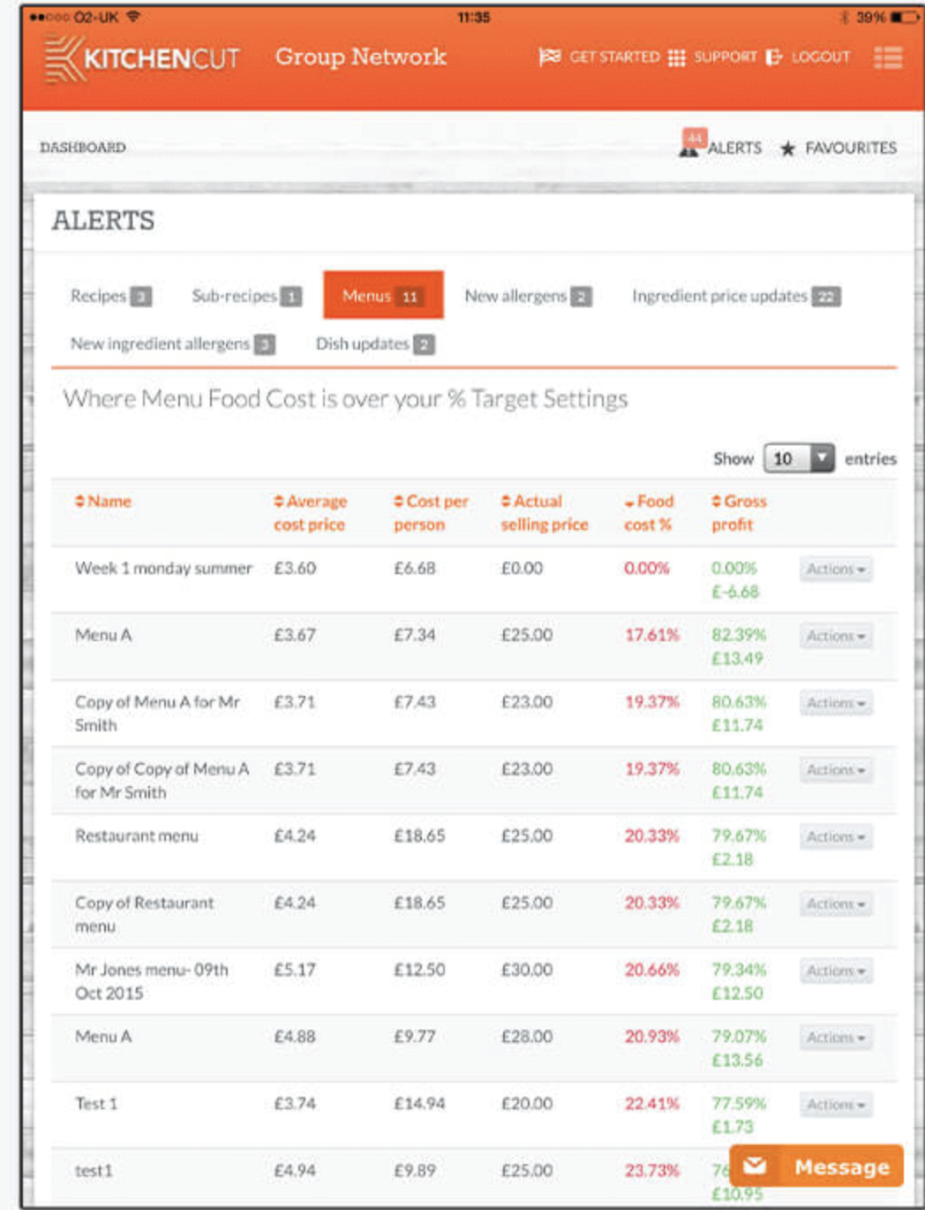
Figure 4 - The interface that a manager would see showing details related to menu items and cost.
As can be seen in figure 4 the interface KitchenCut uses is similar to that of SimpleOrder providing a clean easy to use interface that will be easy to learn and familiar to people already used to working with data in tables. In the above example the page shows costs of menu items vs selling price to show profitability of each meal to the restaurant.

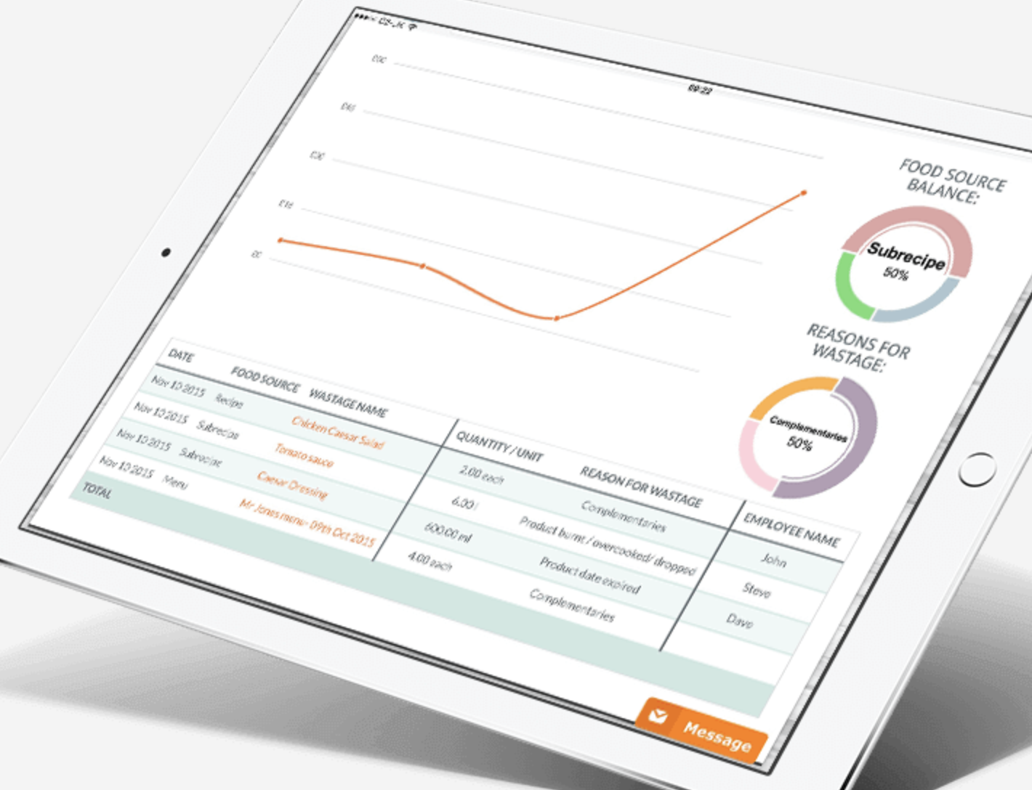
Figure 5 - Interface showing a graphical representation of showing waste over time
Figure 5 – An example of representing date in a graphical format to the end user. In this example KitchenCut are displaying recent wastage including details such as the type of wastage and reason for wastage. A graphical representation could be used with CLUK to display not only wastage but also used to show trends of sales made over certain days or periods of time. Restaurant managers can view previous dates (e.g. bank holidays) or trends over a longer time period (e.g. weeks over summer) to forecast how sales may develop in the future. Graphs can be extrapolated to simulate forecasting and help with estimating changes in future orders to fulfill demand whilst minimizing the risk of both running out of stock and of wastage.
Praise for this system, alongside it’s simple to use nature include the follow up training and assistance that is provided as well as its value for money
Although generally considered easy to use, users of the KitchenCut software have complained about problems with the software including no way of seeing or checking in progress orders. Once an order is sent out by restaurant staff there is no way of accessing that order to check that it has been sent out until it is confirmed the supplier. This could easily cause confusion and either duplicate orders or the absence of a required order. Another criticism was that if suppliers did not complete the product/order sheets then the database mat not be updated. Restaurant had no way of manually changing stock levels so could not amend the database in this situation. This could also be a problem when stock was lost or destroyed.

Based on previous examples a system suitable to meet the client’s needs will include;

- Appropriate software which is easy to use, regardless of their technological skills
- Available of multiple platforms such as desktop, tablet or mobile and website – which should be able to regularly update.
- Include GPS features so delivery drivers can be updated about best routes to take and send reminders to them directly, for example taking a break in long periods of driving.
- Be able to produce inventory reports which users in restaurants, distribution centre and central warehouse can access.
- Able to forecast sales using previous data.
- Connect to Point of Service System (POS) to provide a live status of what stock is available and which stock needs to be replenished in sync with delivery schedules.

  - Analysis

Stakeholders involved include:

- Restaurant managers & staff – The managers of the five restaurants need to be able to order more stock when required. They will need to have knowledge of the stock they currently have in their restaurant. It may be helpful if they also have prompted information on stock levels that are currently low and need reordering. As an extension of the software it is recommended that stock is automatically updated concurrently with customer orders within the restaurant

- Delivery drivers - the design must be made in such a way that it is easy for the drivers to use and to tell them where they need to go. It must always incorporate the required breaks that the drivers must take after set time periods. The software needs to be able to calculate and deliver an efficient driving route to each driver whilst being aware of limitations such as drivers only being able to work up to10 hours each shift, requiring a 45 minute break after every 4.5 hours of driving.

- Distribution centre staff – The staff here will need to know what stock is to be sent where. The software will need to help them plan accordingly considering limitations such as when deliveries can be made (Monday – Friday, minimum 3 days between each delivery, warehouse opens at 5am, restaurants open to delivery between 7am – 8pm. The software must also help the staff with considerations such as managing the effective use of the limited number of drivers as well as prioritising restaurants not only those who have lower stock levels at that time but the busier restaurants whose stock is more likely to be depleted / risk of higher loss of earnings.

Our software could therefore have different areas that apply to the different ‘departments’ of staff so only the area that is relevant to that particular member of staff is visible to them (e.g. drivers only need to know routes and times / working schedules – not what specifically they are delivering)

  - Scope

Project scope is the process of ensuring that the project deliverables and project boundaries are known to those about to start the project. For the purposes of this project the deliverables of the project, essentially that which is understood to be within the scope, are as follows:

In scope

- The development of a web based system for the central warehouse and restaurants of CLUK, essentially the purpose of the project.

- To keep track the amount of stock at the central warehouse and restaurants and indicate if stock is running low at the warehouse and given restaurant.

- Making sure the project contains function which allows for restaurants to request items for their next delivery.

- Usability for a delivery driver to generate a delivery schedule.

Out scope

- The distribution centre offers only restaurants with a radius of about 50 miles for distribution. In other words, the system does not offer distribution and management of restaurants 50 miles away.

- The system only displays warehouse stocks. It is not concerned with cluk’s suppliers and how to provide source of supply.

- The system only displays restaurant inventory and sales. Users cannot trade the stock through the system.

- Although the system will attempt to reduce waste in CLUK’s distribution network it will not be concerned with the company’s budget or spending power for stock.

  - Risk analysis

- Resource allocation risk
When there are more people, the demand for a restaurant increases. Sharply reduced inventory and resource allocation risk, i.e. supply-demand matching.
Solutions:
- By using forecasting from the restaurants business, we can analyse the predicted peak times in the week for the business and from that calculate when is the most efficient times to complete deliveries.
- Also, a Point of Sales System (P.O.S) is useful to give metrics on the current number of sales.
2. Information update risk
Information cannot be updated in real time
Solutions:
- Measures can be taken in advance to prevent information updates from failing by predicting the peak period of restaurants.
- Also, a Point of Sales System (P.O.S) is useful to give metrics on the current number of sales.
3. System overloading risk
During the peak period, multiple users will be accessing the system at the same time, this will carry risks such as updating the database for all users when changes are made – the system will need to be able to deal with this.
Solutions:
- Prototyping allows us to test this before we complete the system to ensure that multiple users can interact with the system.
- Testing - testing team within our group to ensure system works?
- Ensuring the system can handle more than the required estimated number of users. I.e. if we believe 100 people will use it, test it for 150.
4. Technology risk
In the process of system development, we encountered unsolvable technical problems, resulting in incomplete realisation of system functions or system vulnerabilities.
Solutions:
- Structure our work - timelines
- Swap languages if it is impossible - depends on time left
- Have a risk analysis to ensure we have backups.
- Compromises to be made to specification in emergency.

5. If the rider's delivery address is wrong, how to solve it?
Solution:
- Ensure the delivery address is posted in more than 1 place, i.e. drivers schedule and the order number.

6. Team member drops out
If a person resigns or leaves the team for other reasons, how to avoid the risk that will happen soon?
Solutions:
- Have 2 people working on a piece of work to ensure we can take over.
- Pass all the work over from that person before they leave.
- Use git and safe storage methods to ensure we always have access to peoples work.
- Paired programming.

7. Time runs out
Solutions:
- Compromise on the included features
- Ensure minimum requirements are met
- Put more time into the team project.
- Shift people from one area of the project to another.

8. Database system failure
Solutions:
- Information from the web server can be stored locally on machines so that they can get the last saved version of the database.
9. Delivery drivers unable to connect to web server
Drivers will be out of Wi-Fi range inside their vehicles.
Solutions:
- Offline storage of routes of drivers so they can refer to their schedule regardless of internet connection. Make sure these offline maps are kept updated.
10. Required team technical skills
The project involves database creation, back end development, front end development and testing. The team may not have experience in every aspect of the project.
Solutions:
- Knowledge share in group meetings to ensure that the team understand each other’s work
- Attend drop in sessions next semester for help with PHP or java development.
- Smaller groups for each section of the project. Not giving a single person too much responsibility.
11. Size of project & scheduling
Due to the limited time to complete the project keeping on track will be difficult for the team. Other modules are running concurrently with the group project.
Solutions:
- Adopt a methodology that implements rapid development and quick progress
- Weekly meetings and updates on issues regarding implementation
- Reallocating project resources to ensure all areas of the development are well supported.
12. Usability of software for stakeholders
The technical expertise of different stakeholders will be different. Therefore the software must have a high level of usability and accessibility.
Solutions:
- Engaging with our stakeholders regularly throughout the development process to ensure that the solution is meeting the stakeholders needs.
13. Teamwork
The team may have different visions for the direction that the project will go and how the end product will function.
Solutions:
- Agreement in meetings from team members on a single direction for the project.
- Good leadership to resolve conflicts within the team and keep the team focused.
14. Reducing waste
The stock in the business may go out of date at different times and even though the restaurant shows it has a lot of stock that may expire at the same time.
Solutions:
- Expiration dates included on stock and shown in the details of stock levels for each item.
15. Security
The database will hold and transfer sensitive information regarding employees and the business.
Solutions:
- Secure file transfer from server to clients
- Encrypted information.

- Hardware and software platforms to be used for developing and running your solution

Hardware
The hardware utilised for the project is a web server which is running as a shared-kernel server inside a virtual machine. Two of these virtual machines are being ran at once on a single physical server. The physical server itself runs an Intel Xeon CPU with a clock speed of 3.0GHz and 1024 KB of cache, along with 2GB of RAM. As there is limited memory available, care needs to be taken to ensure that memory use stays well under the limit in order to allow for satisfactory performance during peak usage of the system.
The program will be accessed via a website which means it will be able to run on any modern web browser. This will allow users to access it on a wide range of client devices such as desktop PC’s, laptops, tablets, and smartphones.

Software

The project will be based on a web service that allows users to log in and see the relevant information for the particular stakeholder. To do this there are two main components of the web service, the server side and the client side. The client side of the software is what the users will interact with and is a well-designed interpretation of the information stored on the server side/database. Users are able to perform actions via the web application, which will trigger a response from the server side. This information is transferred in the form of a packet, usually xml, CSV or JSON.

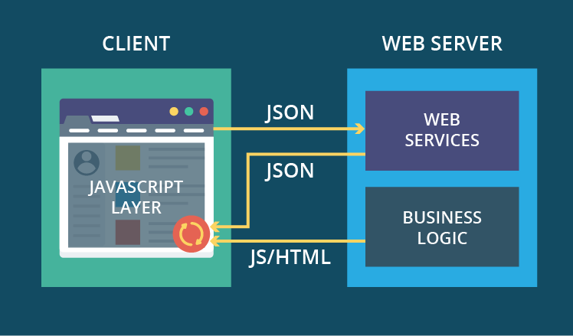
https://www.scnsoft.com/blog/web-application-architecture

There are two standard ways to implement a web application like this, via a LAMP or MEAN stack. The servers at Newcastle University already have several server side languages installed on them and although it is possible for us to implement a framework like Node.js it will simplify and streamline the project if the team uses either Java or PHP for the server side development.

Each of these languages has pros and cons but ultimately whichever language the team choose will need to be understood by all involved. An initial investigation suggests that a LAMP stack would be the most effective implementation methodology for the team as the technologies are being taught to us and supported by the university.

The client side technologies are a much simpler choice as HTML, CSS and JavaScript are present on most modern websites and a natural choice. These languages have not currently been taught to the group but are in the second semester in CSC8004.

- Solution requirements
  - Functional Requirements

The functional requirements have been listed below including an order of priority from high to low. These have been based on the requirements document that was given to us at the beginning of the project and anything listed there has been labeled as a high priority. Many of the Low priority functionalities will be extensions of our work.

Requirement | Priority  (H, M, L)
- Warehouse can request drivers to be sent out for deliveries | High
- Warehouse and restaurants can request to see stock levels | High
- Restaurants will be warned of low stock levels | High
- Each order will include an order number | High
- Each order will have a designated driver | High
- A driver will have a delivery schedule | High
- Drivers will see their order numbers and order details | High
- Drivers will can view the optimal route for their deliveries | High
- Stock can be manually updated at the end of each day by the restaurant manager. | High
- Provide an interface for users. | High
- Different login screens for each user | High
- Multiple users can access the system as the same time | High
- Managers will be unable to order less than 2 units | High
- The warehouse is able to search for current deliveries | Medium
- Drivers are able to access on a mobile device | Medium
- Drivers will be alerted to take a break | Medium
- Search functionality for certain stock items at the warehouse | Medium
- Managers can have an ETA for deliveries | Low
- Restaurant staff can filter views (i.e. vegetarian items only) | Low
- Drivers can see their previous deliveries | Low
- Restaurant Managers can see delivery driver name | Low
- Managers can create new menu items | Low
  - Non-Functional Requirements

The non-functional requirements are all categorized as a high priority and attempt to give information about how a user will be able to do the functional requirements.

- The System will be available on the most popular browsers (Firefox, Chrome, Internet Explorer)
- The system will protect the user’s details and information via an encryption method
- The warehouse driver requests will be sent via email to the drivers.
- Stock levels will be displayed on request after logging into an online portal. The website will have a function call to request this information.
- When an order is created a unique delivery order number will be generated and added to the order.
- Drivers will be able to log into the portal and view their schedule for the week by a request function.
- Stock available in the restaurant can be updated twice daily, at the beginning and end of a day by the manager to ensure stock is available.
- Drivers will be sent an alert when they are due to take a break. This will be based on the time spent driving via a journey started option in the portal.
- Using the system, the warehouse staff can action the creation and implementation of a driver’s delivery schedule.
- Restaurants have access to see inventory levels at the restaurant from the end of the previous day. Warehouses have access to both its own stock and that of each of the five restaurants.
- At predefined stock levels specific to each item. The system will trigger an alert to the restaurant when a lower threshold has been reached.
- The system will automatically assign an order number upon generation of that order.
- A specific driver will be assigned to a schedule upon creation of that schedule. This will be done manually by a worker at the warehouse when creating the schedule
- The will be functionality that allows for drivers to log into the system on a mobile device. It will show all details such as order numbers and order of destinations (determined by staff at warehouse. Google Maps will provide route optimisation based on destinations & other factors (traffic, road closures.)
- The system will allow for restaurant manager to make deductions from the stored inventory levels based on erroneous events such as spoiling of stock / accidental damage.
- System will consist of web browser interfaces on both desktop and mobile devices and will have specific functionality depending on the type of user. Drivers will see information relevant to them e.g. routes and driving time whilst restaurant managers will see information such as low stock warnings and access to order forms.
- Different users of the system will be presented with different log in screens to then access an interface with user specific functionality.
- The system allows for concurrent usage. Multiple drivers, restaurant staff and warehouse staff can all access the system at the same time with no problems.
- When a restaurant manager places an order, the system will automatically prevent the manager from being able to order below the minimum limit i.e. two units. This will be achieved by the option for confirming an order being greyed out until the criteria (at least two units ordered) has been fulfilled.

- Other considerations

  - Assumptions

- Each restaurant receives 2 deliveries per week which occur between 07:00-20:00 Monday to Friday with a minimum of 3 days between each delivery.

- The warehouse is open to delivery drivers from 05:00-21:00.

- Some restaurants will have more customers than others; restaurants in town centres generate more custom and therefore require more stock to be delivered.

- There are enough delivery drivers to deliver to all the stores.

- Drivers have a maximum of 10 hours per shift.

- Drivers must take a 45-minute break after driving for 4.5 hours.

- Delivery drivers must return to the distribution centre to end their shift.

- Delivery drivers can always use the same roads between destinations with the same journey time; traffic is not an issue and there will never be any road closures.

- Deliveries to stores cannot occur on Wednesdays as this would violate the requirements of having 2 weekday deliveries per week with a minimum of 3 days in-between.

- Delivery drivers can stop anywhere along their route for their breaks.

- Loading of vehicles at the distribution centre and unloading of deliveries at restaurants takes 30 minutes.

- Once an order has been placed by a restaurant it is fixed and will not change.

- Restaurants update their stock inventory at the start and end of each day.

- Food items will have an expiration date once they have left the distribution centre and will be disposed of once going out of date.

- Restaurants will always use the stock that is closest to its expiration date.

  - Constraints and Dependencies

- No money for budget therefore cannot utilise proprietary software

- Can’t recruit any additional members to the team

- Team skills may be limited to certain programming languages

- If a team member leaves the work load will have to be reallocated

- If a team member with a specific skill aiding the project leaves it may require a redesign of the project.

- The client could change their requirements – this could cause a change to the functionality of the program or a change of program entirely

- The client could open a new restaurant while the project is taking place so it would add to the list of requirements.

- If the client changes the location of the restaurants and distribution centre.

- The client wants to add new items to the menu at a later stage of the project or make amendments to the ingredients of a restaurant, such as quantity, type or their price

- Client changes the minimum amount of delivery days.

- Drivers can only work a maximum of 10 hours in a shift and must have a break after 4.5 hours for 45 minutes

- Initial requirements analysis of user interaction

5.1 Initial ideas for a GUI.

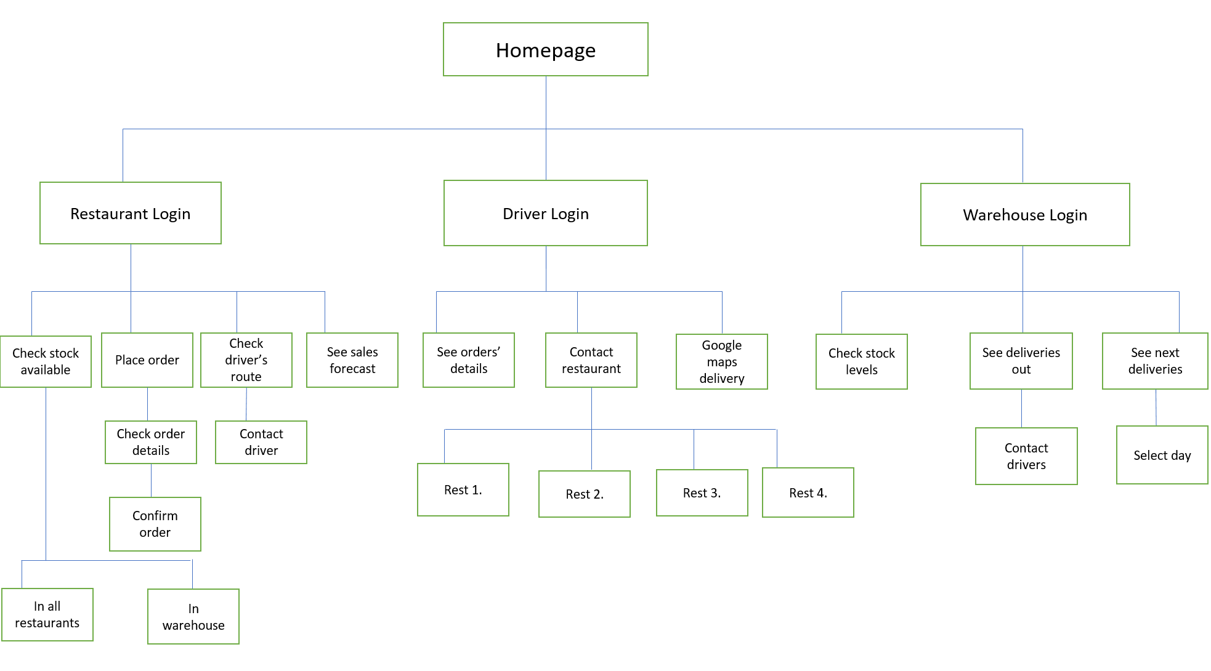

5.2 Website Design

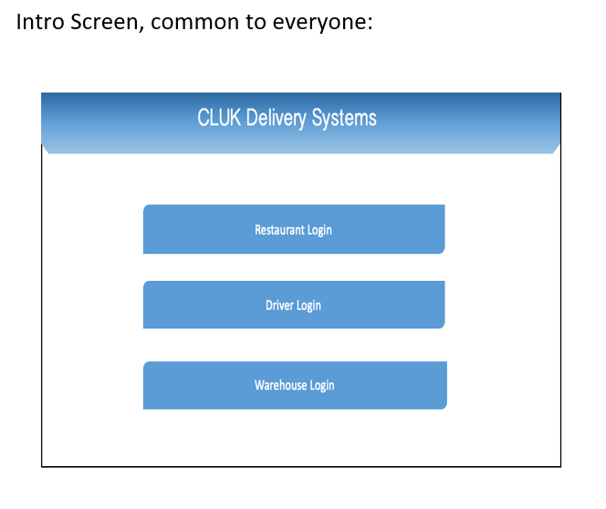
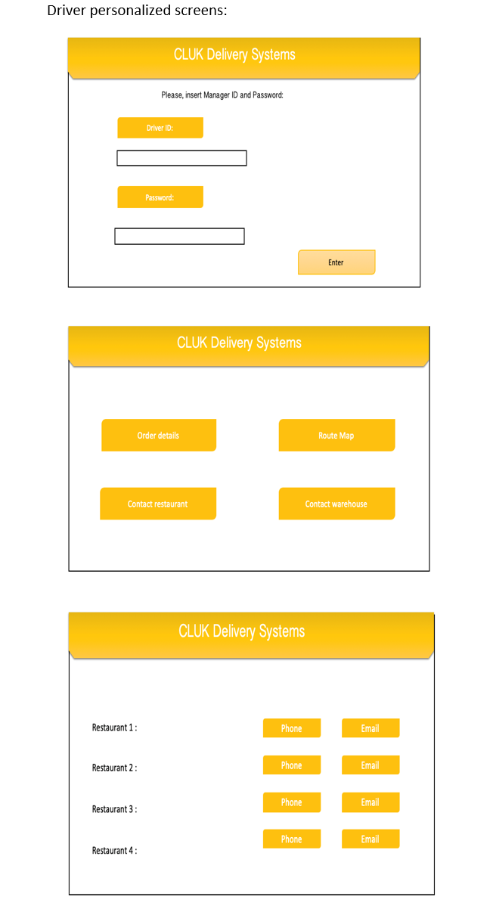

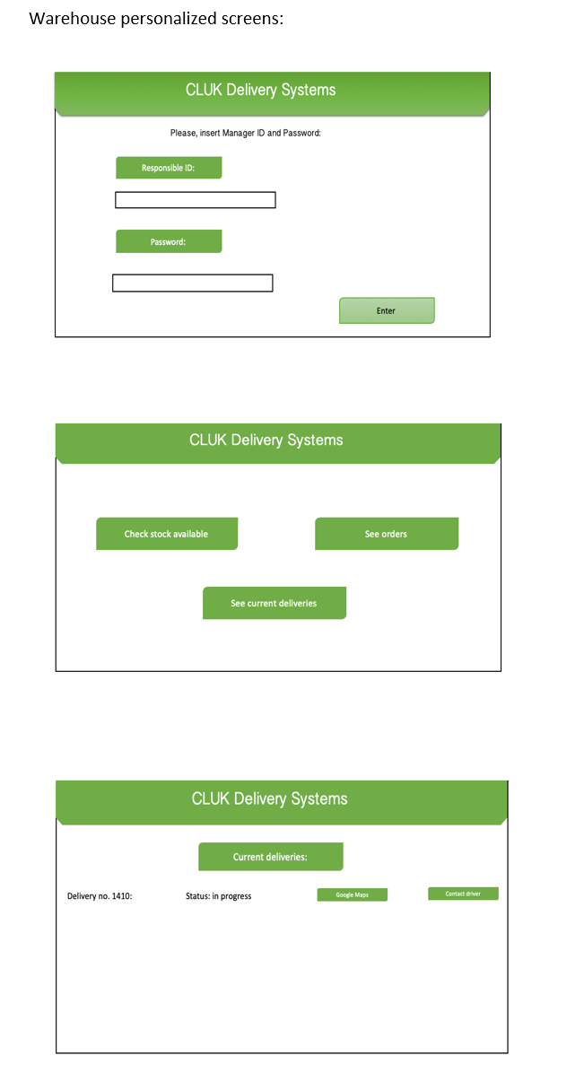
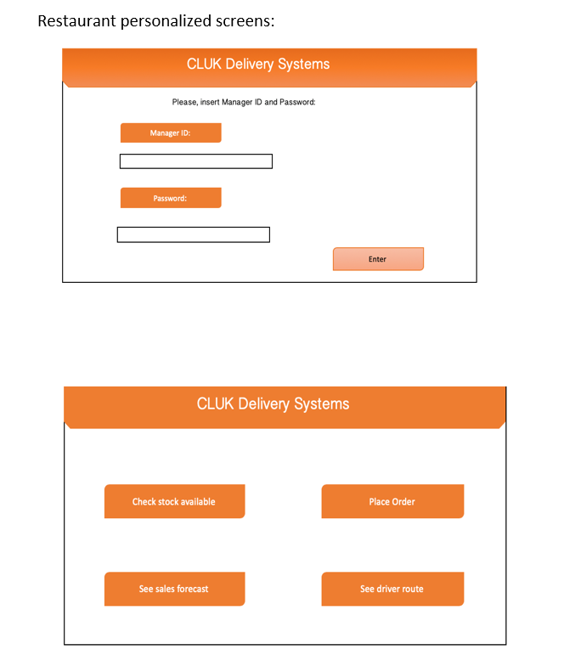
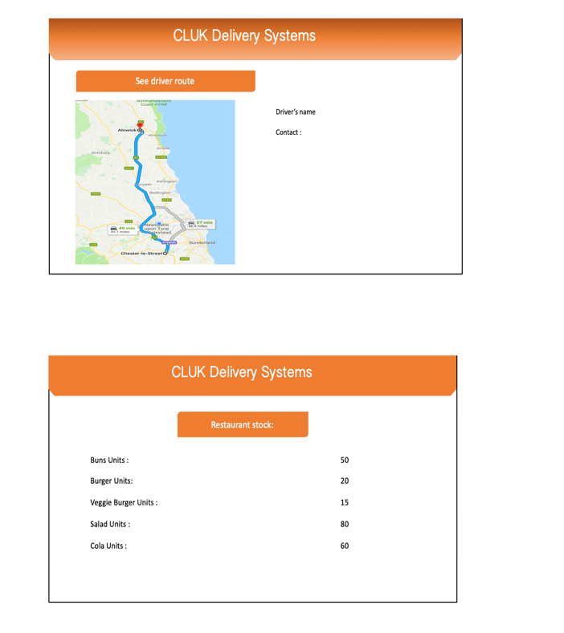
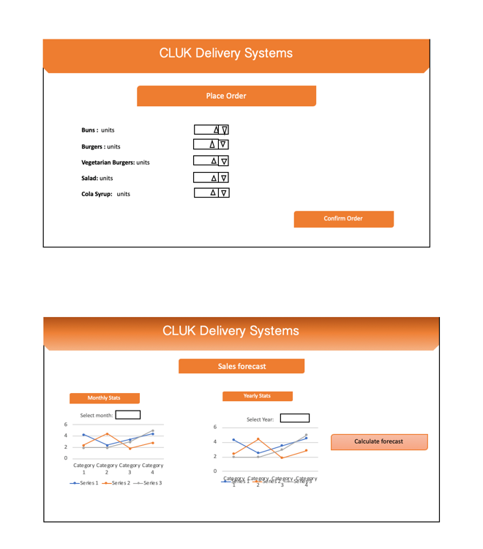

- UML Diagram
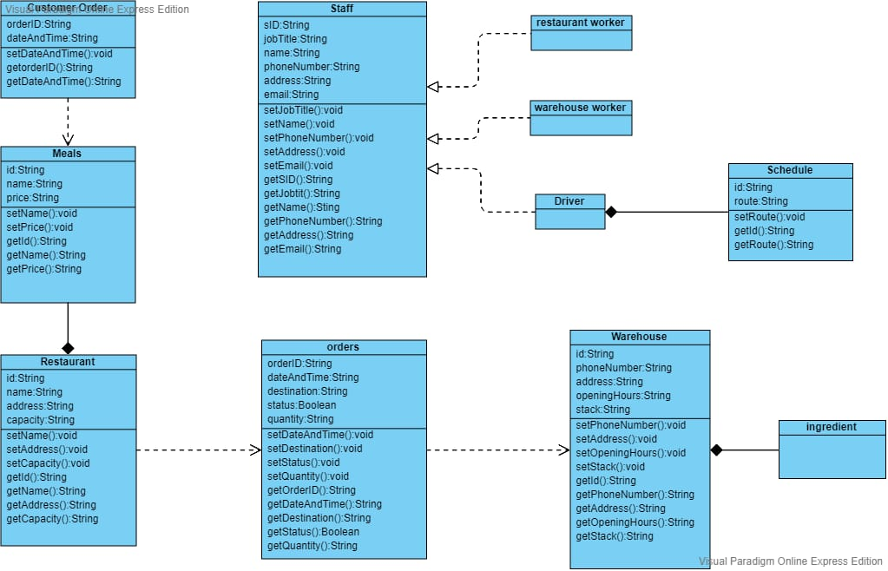

- Use cases – Describe how the user accesses functionality.
  - Use Case Diagram
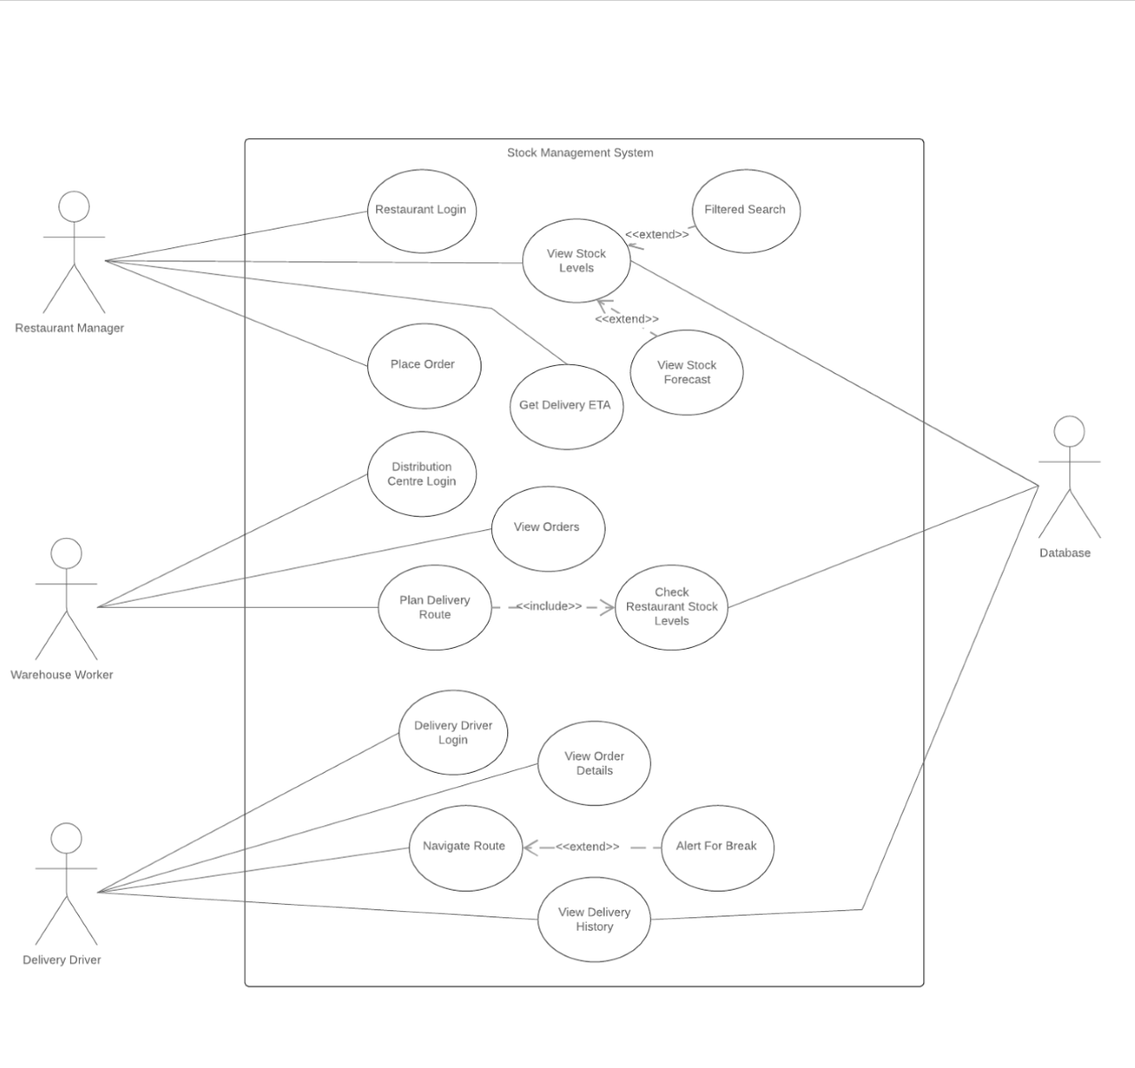

7.2 User access

- Warehouse can request drivers to be sent out for deliveries
User action  User choose which order to be delivered  User click button “find a driver”  User choose the driver  User click “yes” | System response  1.show order details  2.show list of drivers (with ETA)  3.show decision page (yes or no)  4.system show “delivery made” | P / F

- Warehouse and restaurants can request to see stock levels
User action  User click button “stock” | System response  Show stock table (with a filter of food type and amount) | P / F

- Restaurants will be warned of low stock levels
User action  Open main page  Enter notification center | System response  1.notification center show waring of “low stock of ”+food type  2.show details of the type in low stock | P / F

- Each order will include an order number
User action  Enter order details and click “make order” | System response  Show a order receipt with unique order number | P / F

- Each order will have a designated driver
Arrange driver for each order
User action  Enter order details and click “make order” | System response  Auto add driver with littlest ETA at current time | P / F

- A driver will have a delivery schedule
Give drivers delivery schedule
User action  Enter module “schedule” | System response  1.Send restaurant names to map apps  2.Receive recommended route from map apps  3.Calculate estimate time for each route  4.Arrange schedule  5.Show the schedule to the driver | P / F

- Drivers will can view the optimal route for their deliveries
User action  Enter module “schedule”  Click “show routes” | System response  1.Send restaurant names to map apps  2.Receive recommended route from map apps  3.Show routes on the screen | P / F

- The warehouse is able to search for current deliveries
User action  Enter relevant information about stock(food type) | System response  List details of the input | P / F

- Drivers will be alerted to take a break
User action  Drive over 4 hours | System response  1.Sence the driving status through map apps  2.Send alert when driving over 4 hours | P / F

- Managers can have an ETA for deliveries
User action  Finish making order  Click “orders” menu | System response  1.Show estimate time of arrival of certain order | P / F

- Restaurant staff can filter views (i.e. vegetarian items only)
User action  Click on table titles | System response  1.Flit information of names, amount, types | P / F

- Restaurant Managers can see delivery driver name
User action  Click “orders” menu | System response  1.Show the driver information in the order page | P / F

- Managers can create new menu items
User action  Click “Add new menu” button  Enter materials of this menu  Save menu | System response  1.Create a new menu table for this restaurant

8. References – to all documents you use e.g. for research and also the initial Project Brief etc

Yaskevich, A.Y. 2019. Web application architecture: Components, models and types. [Online]. [9 April 2019]. Available from: https://www.scnsoft.com/blog/web-application-architecture

9. Definition of terms

- Client Side: This is what a user of the system will see when they access the website on their machines
- Clock speed: The speed at which a processor executes instructions; measured in cycles per second (hertz).
- CLUK: Chicken Lovers United Kingdom
- CSS: Cascading Style Sheets are used to describe HTML on a web page.
- CPU: The central processing unit of a computer where software is run and calculations take place.
- CPU Cache: Small capacity, fast memory contained inside the CPU which is used to store data for immediate use in calculations.
- CSV: comma-separated values. This is a file stored with a comma as the delimiter.
- Client Side: This is what a user of the system will see when they access the website on their machines
- Database: A structured set of data held in a computer, especially one that is accessible in various ways.
- GPS: Global Positioning System
- JavaScript: Programming language often used to build dynamic web pages.
- JSON: JavaScript Object Notation is a file type that can be fixable in its storage format. Can be used in databases or for file transfer commonly.
- HTML: Hypertext Mark-up Language is the standard language used for building web pages and web applications
- Kernel: The computer program at the centre of the operating system that controls all other programs in the system.
- LAMP: Stands for the first letters of a stack of standard languages used to host a website. Linux, Apache, MySQL and PHP.
- MEAN: Stands for the first letters of a stack of standard languages used to host a website. MongoDB, Express.js, Angular.js and Node.js
- POS: Point of Service System
- RAM: Random access memory which the computer uses to store files the CPU is currently using.
- Server Side: This is what the code base underneath the system is doing and is seen by the programmers. It is obscured from the users view.
- Virtual Machine: A software representation of a physical computer which runs an operating system and programs. Virtual machines run on a physical host system and provide the same functionality as the physical machine which they are imitating.
- Xml: Extensible Mark-up Language is one of the possible file types we can use for transfer of information. It has a fixed notation for usage.

- GANNT Chart
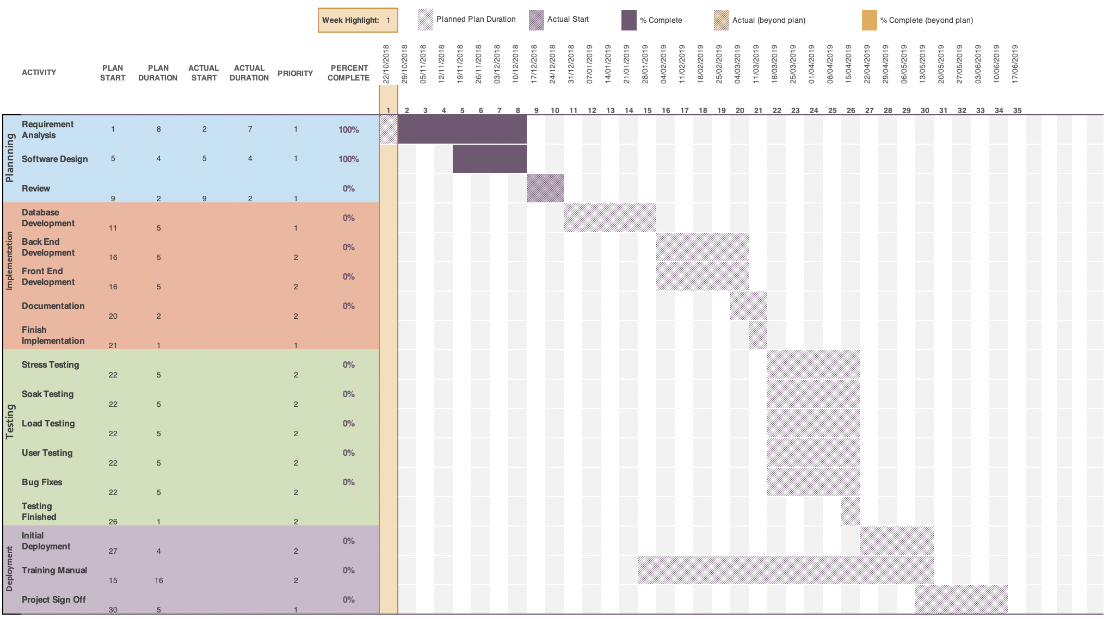

SimpleOrder website https://simpleorder.com
KitchenCut website https://www.kitchencut.com

